Marcus Zambito

CS-330

Milestone 1

I have chosen the following photo for my 3D replication: 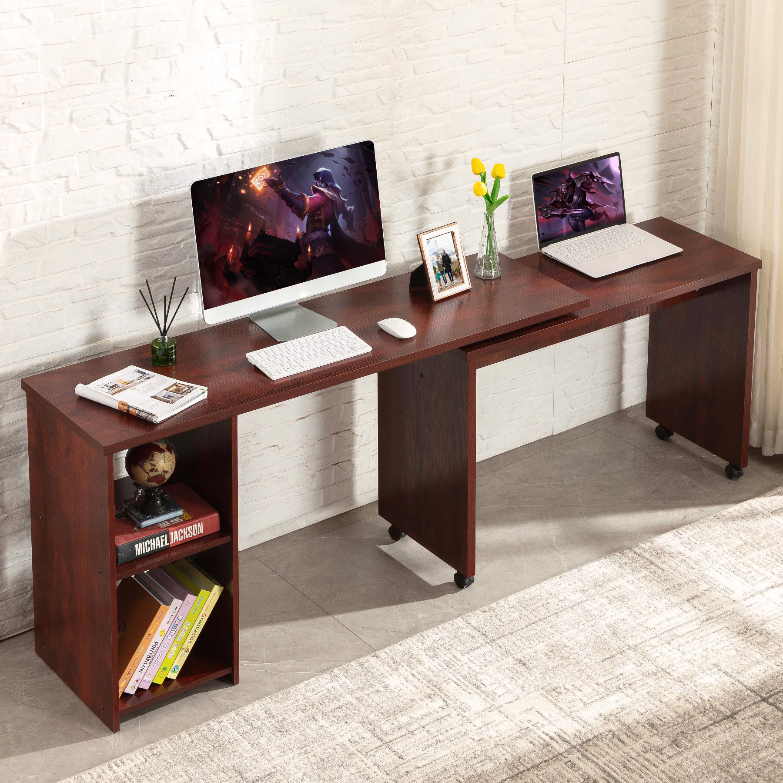

I will be replicating the apple monitor, Vase, incense holder, and keyboard. These shapes, while simple, are different enough to practice multiple different shapes and connections, while encouraging creativity with placement. I plan for the desk itself to operate as my plane; The monitor will be replicated using a elongated box, plane, and another plane for its stand. The incense holder will be replicated using a cylinder for its base, a secondary cylinder for its incense holder, and most likely tapered cylinders for the incense themselves- Tapered is preferred over regular cylinders because of the pointed ends on incense. The keyboard will be replicated by an elongated box and multiple raised planes for the keys.